Lab - Troubleshooting Connectivity Issues

1. Topology



1. Addressing Table

|  |  |  |  |  |
| --- | --- | --- | --- | --- |
| Device | Interface | IP Address | Subnet Mask | Default Gateway |
| R1 | G0/1 | 192.168.1.1 | 255.255.255.0 | N/A |
| S0/0/0 | 10.1.1.1 | 255.255.255.252 | N/A |
| ISP | S0/0/0 | 10.1.1.2 | 255.255.255.252 | N/A |
| Lo0 | 209.165.200.226 | 255.255.255.255 | N/A |
| S1 | VLAN 1 | 192.168.1.2 | 255.255.255.0 | 192.168.1.1 |
| PC-A | NIC | 192.168.1.10 | 255.255.255.0 | 192.168.1.1 |

1. Objectives

Part 1: Identify the Problem

Part 2: Implement Network Changes

Part 3: Verify Full Functionality

Part 4: Document Findings and Configuration Changes

1. Background / Scenario

In this lab, the company that you work for is experiencing problems with their Local Area Network (LAN). You have been asked to troubleshoot and resolve the network issues. In Part 1, you will connect to devices on the LAN and use troubleshooting tools to identify the network issues, establish a theory of probable cause, and test that theory. In Part 2, you will establish a plan of action to resolve and implement a solution. In Part 3, you will verify full functionality has been restored. Part 4 provides space for you to document your troubleshooting findings along with the configuration changes that you made to the LAN devices.

**Note**: The routers used with CCNA hands-on labs are Cisco 1941 Integrated Services Routers (ISRs) with Cisco IOS Release 15.2(4)M3 (universalk9 image). The switches used are Cisco Catalyst 2960s with Cisco IOS Release 15.0(2) (lanbasek9 image). Other routers, switches, and Cisco IOS versions may be used. Depending on the model and Cisco IOS version, the commands available and the output produced might vary from what is shown in the labs. Refer to the Router Interface Summary Table at the end of this lab for the correct interface identifiers.

1. Required Resources

* 2 Router (Cisco 1941 with Cisco IOS Release 15.2(4)M3 universal image or comparable)
* 1 Switch (Cisco 2960 with Cisco IOS Release 15.0(2) lanbasek9 image or comparable)
* 1 PC (Windows 7 or 8 with terminal emulation program, such as Tera Term)
* Ethernet and Serial cables as shown in the topology

1. Troubleshooting Configurations

The following settings must be configured on the devices shown in the topology. Paste the configurations onto the specified devices prior to starting the lab.

S1:

no ip domain-lookup

hostname S1

ip domain-name ccna-lab.com

username admin01 privilege 15 secret cisco12345

interface FastEthernet0/1

shutdown

interface FastEthernet0/2

shutdown

interface FastEthernet0/3

shutdown

interface FastEthernet0/4

shutdown

interface FastEthernet0/5

duplex full

interface Vlan1

ip address 192.168.1.2 255.255.255.0

line vty 0 4

login local

transport input ssh

line vty 5 15

login local

transport input ssh

crypto key generate rsa general-keys modulus 1024

end

R1:

hostname R1

no ip domain-lookup

ip domain-name ccna-lab.com

username admin01 privilege 15 secret cisco12345

interface GigabitEthernet0/0

shutdown

interface GigabitEthernet0/1

ip address 192.168.1.1 255.255.255.0

duplex half

speed auto

no shutdown

interface Serial0/0/0

ip address 10.1.2.1 255.255.255.252

no shutdown

interface Serial0/0/1

no ip address

shutdown

line vty 0 4

login local

transport input ssh

crypto key generate rsa general-keys modulus 1024

end

ISP:

hostname ISP

no ip domain-lookup

interface Serial0/0/0

ip address 10.1.1.2 255.255.255.252

no shut

interface Lo0

ip address 209.165.200.226 255.255.255.255

ip route 0.0.0.0 0.0.0.0 10.1.1.1

end

1. Identify the Problem.

The only available information about the network problem is that the users are experiencing slow response times and that they are not able to reach an external device on the Internet at IP address 209.165.200.226. To determine probable cause(s) for these network issues, you will need to utilize network commands and tools on the LAN equipment shown in the topology.

**Note**: The user name **admin01** with a password of **cisco12345** will be required to log into the network equipment.

* 1. Troubleshoot from the PC.
     1. From the PC command prompt, **ping** the external server IP Address **209.165.200.226**.

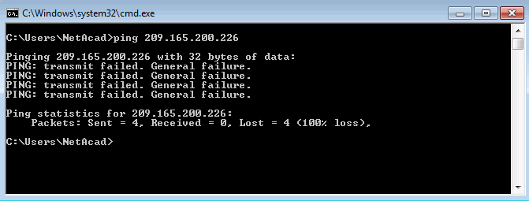

* + 1. Use the **ipconfig** command to determine the network settings on the PC.

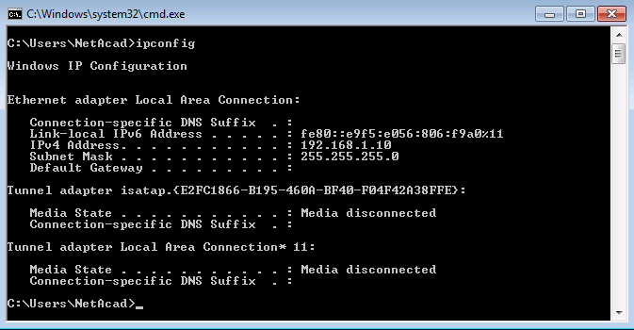

* 1. Troubleshoot from S1 using a SSH client session.

**Note**: Any SSH client software can be used. Tera Term is used in the examples in this lab.

* + 1. SSH to S1 using its IP Address of 192.168.1.2 and log into the switch using **admin01** for the user name and **cisco12345** for the password.

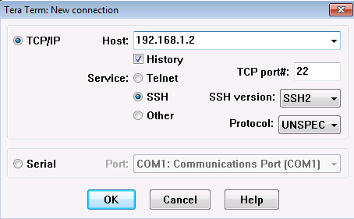

* + 1. Issue the **terminal monitor** command on S1 to allow log messages to be sent to the VTY line of your SSH session. After a few seconds you notice the following error message being displayed in your SSH window.

S1# **terminal monitor**

S1#

*Mar 1 02:08:11.338: %CDP-4-DUPLEX_MISMATCH: duplex mismatch discovered on FastEthernet0/5 (not half duplex), with R1.ccna-lab.com GigabitEthernet0/1 (half duplex).

S1#

* + 1. On S1, issue the **show interface f0/5** command to view the duplex setting of the interface.

S1# **show interface f0/5**

FastEthernet0/5 is up, line protocol is up (connected)

Hardware is Fast Ethernet, address is 0cd9.96e8.8a05 (bia 0cd9.96e8.8a05)

MTU 1500 bytes, BW 100000 Kbit/sec, DLY 100 usec,

reliability 255/255, txload 1/255, rxload 1/255

Encapsulation ARPA, loopback not set

Keepalive set (10 sec)

Full-duplex, 100Mb/s, media type is 10/100BaseTX

input flow-control is off, output flow-control is unsupported

ARP type: ARPA, ARP Timeout 04:00:00

Last input 00:00:35, output 00:00:01, output hang never

Last clearing of "show interface" counters never

Input queue: 0/75/0/0 (size/max/drops/flushes); Total output drops: 0

Queueing strategy: fifo

Output queue: 0/40 (size/max)

5 minute input rate 0 bits/sec, 0 packets/sec

5 minute output rate 0 bits/sec, 0 packets/sec

849 packets input, 104642 bytes, 0 no buffer

Received 123 broadcasts (122 multicasts)

0 runts, 0 giants, 0 throttles

0 input errors, 0 CRC, 0 frame, 0 overrun, 0 ignored

0 watchdog, 122 multicast, 0 pause input

0 input packets with dribble condition detected

4489 packets output, 361270 bytes, 0 underruns

0 output errors, 0 collisions, 1 interface resets

0 unknown protocol drops

0 babbles, 0 late collision, 0 deferred

0 lost carrier, 0 no carrier, 0 pause output

0 output buffer failures, 0 output buffers swapped out

S1#

* 1. Troubleshoot on R1 using an SSH client.
     1. SSH to R1’s LAN interface and log in using **admin01** for the user name and **cisco12345** as the password.

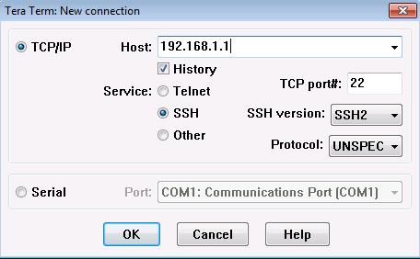

* + 1. Issue the **terminal monitor** command on R1 to allow log messages to be sent to the VTY line of your SSH session for R1. After a few seconds the duplex mismatch message appears on R1’s SSH session.

R1# **terminal monitor**

R1#

*Nov 23 16:12:36.623: %CDP-4-DUPLEX_MISMATCH: duplex mismatch discovered on GigabitEthernet0/1 (not full duplex), with S1.ccna-lab.com FastEthernet0/5 (full duplex).

R1#

* + 1. Issue the **show interface G0/1** command on R1 to display the duplex setting.

R1# **show interfaces g0/1**

GigabitEthernet0/1 is up, line protocol is up

Hardware is CN Gigabit Ethernet, address is d48c.b5ce.a0c1 (bia d48c.b5ce.a0c1)

Internet address is 192.168.1.1/24

MTU 1500 bytes, BW 100000 Kbit/sec, DLY 100 usec,

reliability 255/255, txload 1/255, rxload 1/255

Encapsulation ARPA, loopback not set

Keepalive set (10 sec)

Half Duplex, 100Mbps, media type is RJ45

output flow-control is unsupported, input flow-control is unsupported

ARP type: ARPA, ARP Timeout 04:00:00

Last input 00:00:15, output 00:00:05, output hang never

Last clearing of "show interface" counters never

Input queue: 0/75/0/0 (size/max/drops/flushes); Total output drops: 0

Queueing strategy: fifo

Output queue: 0/40 (size/max)

5 minute input rate 0 bits/sec, 0 packets/sec

5 minute output rate 0 bits/sec, 0 packets/sec

641 packets input, 101892 bytes, 0 no buffer

Received 453 broadcasts (0 IP multicasts)

0 runts, 0 giants, 0 throttles

0 input errors, 0 CRC, 0 frame, 0 overrun, 0 ignored

0 watchdog, 361 multicast, 0 pause input

1043 packets output, 123698 bytes, 0 underruns

0 output errors, 0 collisions, 1 interface resets

235 unknown protocol drops

0 babbles, 0 late collision, 0 deferred

0 lost carrier, 0 no carrier, 0 pause output

0 output buffer failures, 0 output buffers swapped out

R1#

* + 1. Issue the **ping 209.165.200.226** command on R1 to test connectivity to the external server.

R1# **ping 209.165.200.226**

Type escape sequence to abort.

Sending 5, 100-byte ICMP Echos to 209.165.200.226, timeout is 2 seconds:

.....

Success rate is 0 percent (0/5)

R1#

* + 1. Issue the **show ip interface brief** command on R1 to verify interface IP Address settings.

R1# **show ip interface brief**

Interface IP-Address OK? Method Status Protocol

Embedded-Service-Engine0/0 unassigned YES unset administratively down down

GigabitEthernet0/0 unassigned YES unset administratively down down

GigabitEthernet0/1 192.168.1.1 YES manual up up

Serial0/0/0 10.1.2.1 YES manual up up

Serial0/0/1 unassigned YES unset administratively down down

R1#

* + 1. Issue the **show ip route** command on R1 to verify the router’s default gateway setting.

R1# **show ip route**

Codes: L - local, C - connected, S - static, R - RIP, M - mobile, B - BGP

D - EIGRP, EX - EIGRP external, O - OSPF, IA - OSPF inter area

N1 - OSPF NSSA external type 1, N2 - OSPF NSSA external type 2

E1 - OSPF external type 1, E2 - OSPF external type 2

i - IS-IS, su - IS-IS summary, L1 - IS-IS level-1, L2 - IS-IS level-2

ia - IS-IS inter area, * - candidate default, U - per-user static route

o - ODR, P - periodic downloaded static route, H - NHRP, l - LISP

a - application route

+ - replicated route, % - next hop override

Gateway of last resort is not set

10.0.0.0/8 is variably subnetted, 2 subnets, 2 masks

C 10.1.2.0/30 is directly connected, Serial0/0/0

L 10.1.2.1/32 is directly connected, Serial0/0/0

192.168.1.0/24 is variably subnetted, 2 subnets, 2 masks

C 192.168.1.0/24 is directly connected, GigabitEthernet0/1

L 192.168.1.1/32 is directly connected, GigabitEthernet0/1

R1#

List the probable causes for the network problems that employees are experiencing.

____________________________________________________________________________________

____________________________________________________________________________________

____________________________________________________________________________________

____________________________________________________________________________________

1. Implement Network Changes

You have communicated the problems that you discovered in Part 1 to your supervisor. She has approved these changes and has requested that you implement them.

* 1. Set the Default Gateway on the PC to 192.168.1.1.

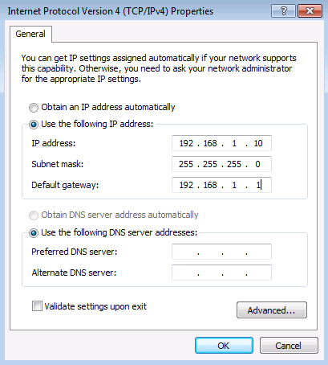

* 1. Set the duplex setting for interface G0/1 on R1 to full duplex.

R1# **conf t**

Enter configuration commands, one per line. End with CNTL/Z.

R1(config)#

*Nov 23 17:23:36.879: %CDP-4-DUPLEX_MISMATCH: duplex mismatch discovered on GigabitEthernet0/1 (not full duplex), with S1.ccna-lab.com FastEthernet0/5 (full duplex).

R1(config)#

R1(config)# **interface g0/1**

R1(config-if)# **duplex full**

R1(config-if)# **exit**

*Nov 23 17:24:08.039: %LINK-3-UPDOWN: Interface GigabitEthernet0/1, changed state to down

R1(config)#

*Nov 23 17:24:10.363: %LINK-3-UPDOWN: Interface GigabitEthernet0/1, changed state to up

*Nov 23 17:24:10.459: %SYS-5-CONFIG_I: Configured from console by console

R1(config)#

* 1. Reconfigure the IP address for S0/0/0 to IP Address 10.1.1.1/30 on R1.

R1(config)# **interface s0/0/0**

R1(config-if)# **ip address 10.1.1.1 255.255.255.252**

R1(config-if)# **exit**

* 1. Configure the Gateway of last resort on R1 with a 10.1.1.2 default route.

R1(config)# **ip route 0.0.0.0 0.0.0.0 10.1.1.2**

R1(config)# **end**

1. Verify Full Functionality

Verify that full functionality has been restored.

* 1. Verify that all interfaces and routes have been set correctly and that routing has been restored on R1.
     1. Issue the **show ip route** command to verify that the default gateway has been set correctly.

R1# **show ip route**

Codes: L - local, C - connected, S - static, R - RIP, M - mobile, B - BGP

D - EIGRP, EX - EIGRP external, O - OSPF, IA - OSPF inter area

N1 - OSPF NSSA external type 1, N2 - OSPF NSSA external type 2

E1 - OSPF external type 1, E2 - OSPF external type 2

i - IS-IS, su - IS-IS summary, L1 - IS-IS level-1, L2 - IS-IS level-2

ia - IS-IS inter area, * - candidate default, U - per-user static route

o - ODR, P - periodic downloaded static route, H - NHRP, l - LISP

a - application route

+ - replicated route, % - next hop override

Gateway of last resort is 10.1.1.2 to network 0.0.0.0

S* 0.0.0.0/0 [1/0] via 10.1.1.2

10.0.0.0/8 is variably subnetted, 2 subnets, 2 masks

C 10.1.1.0/30 is directly connected, Serial0/0/0

L 10.1.1.1/32 is directly connected, Serial0/0/0

192.168.1.0/24 is variably subnetted, 2 subnets, 2 masks

C 192.168.1.0/24 is directly connected, GigabitEthernet0/1

L 192.168.1.1/32 is directly connected, GigabitEthernet0/1

R1#

* + 1. Issue the **show ip interface s0/0/0** command to verify that the IP Address on S0/0/0 is set correctly.

R1# **show ip interface s0/0/0**

Serial0/0/0 is up, line protocol is up

Internet address is 10.1.1.1/30

Broadcast address is 255.255.255.255

Address determined by setup command

MTU is 1500 bytes

*<output omitted>*

IPv4 WCCP Redirect exclude is disabled

R1#

* + 1. Issue the **ping 209.165.200.226** command to verify that the external server is reachable now.

R1# **ping 209.165.200.226**

Type escape sequence to abort.

Sending 5, 100-byte ICMP Echos to 209.165.200.226, timeout is 2 seconds:

!!!!!

Success rate is 100 percent (5/5), round-trip min/avg/max = 1/2/4 ms

R1#

* + 1. Issue the **show interface g0/1** command to verify that the duplex setting is full duplex.

R1# show interface g0/1

GigabitEthernet0/1 is up, line protocol is up

Hardware is CN Gigabit Ethernet, address is d48c.b5ce.a0c1 (bia d48c.b5ce.a0c1)

Internet address is 192.168.1.1/24

MTU 1500 bytes, BW 100000 Kbit/sec, DLY 100 usec,

reliability 255/255, txload 1/255, rxload 1/255

Encapsulation ARPA, loopback not set

Keepalive set (10 sec)

Full Duplex, 100Mbps, media type is RJ45

output flow-control is unsupported, input flow-control is unsupported

ARP type: ARPA, ARP Timeout 04:00:00

Last input 00:00:04, output 00:00:04, output hang never

Last clearing of "show interface" counters never

Input queue: 0/75/0/0 (size/max/drops/flushes); Total output drops: 0

Queueing strategy: fifo

Output queue: 0/40 (size/max)

5 minute input rate 0 bits/sec, 0 packets/sec

5 minute output rate 0 bits/sec, 0 packets/sec

559 packets input, 74066 bytes, 0 no buffer

Received 279 broadcasts (0 IP multicasts)

0 runts, 0 giants, 0 throttles

0 input errors, 0 CRC, 0 frame, 0 overrun, 0 ignored

0 watchdog, 208 multicast, 0 pause input

742 packets output, 81462 bytes, 0 underruns

0 output errors, 0 collisions, 2 interface resets

133 unknown protocol drops

0 babbles, 0 late collision, 0 deferred

1 lost carrier, 0 no carrier, 0 pause output

0 output buffer failures, 0 output buffers swapped out

R1#

* 1. Verify End-to-End connectivity from the LAN PC.
     1. Issue the **ipconfig** command from the command prompt on the PC.

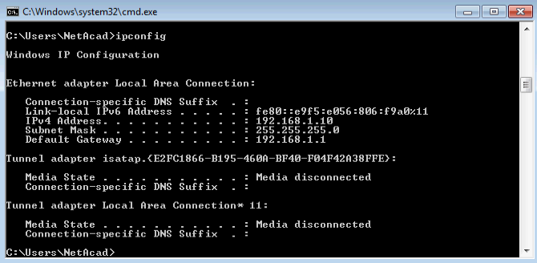

* + 1. Issue the **ping 209.165.200.226** command from the CMD window on the PC

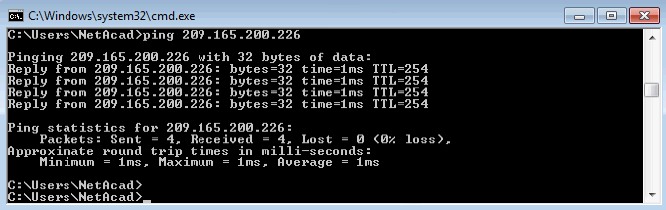

1. Document Findings and Configuration Changes

Use the space provided below to document the issues found during your troubleshooting and the configurations changes made to resolve those issues.

_______________________________________________________________________________________

_______________________________________________________________________________________

_______________________________________________________________________________________

_______________________________________________________________________________________

_______________________________________________________________________________________

_______________________________________________________________________________________

_______________________________________________________________________________________

_______________________________________________________________________________________

_______________________________________________________________________________________

_______________________________________________________________________________________

_______________________________________________________________________________________

_______________________________________________________________________________________

_______________________________________________________________________________________

_______________________________________________________________________________________

_______________________________________________________________________________________

_______________________________________________________________________________________

_______________________________________________________________________________________

_______________________________________________________________________________________

_______________________________________________________________________________________

_______________________________________________________________________________________

1. Reflection

This lab had you troubleshoot all devices before making any changes. Is there another way to apply the troubleshooting methodology?

_______________________________________________________________________________________

_______________________________________________________________________________________

_______________________________________________________________________________________

_______________________________________________________________________________________

_______________________________________________________________________________________

_______________________________________________________________________________________

_______________________________________________________________________________________

1. Router Interface Summary Table

|  |  |  |  |  |
| --- | --- | --- | --- | --- |
| Router Interface Summary | | | | |
| Router Model | Ethernet Interface #1 | Ethernet Interface #2 | Serial Interface #1 | Serial Interface #2 |
| 1800 | Fast Ethernet 0/0 (F0/0) | Fast Ethernet 0/1 (F0/1) | Serial 0/0/0 (S0/0/0) | Serial 0/0/1 (S0/0/1) |
| 1900 | Gigabit Ethernet 0/0 (G0/0) | Gigabit Ethernet 0/1 (G0/1) | Serial 0/0/0 (S0/0/0) | Serial 0/0/1 (S0/0/1) |
| 2801 | Fast Ethernet 0/0 (F0/0) | Fast Ethernet 0/1 (F0/1) | Serial 0/1/0 (S0/1/0) | Serial 0/1/1 (S0/1/1) |
| 2811 | Fast Ethernet 0/0 (F0/0) | Fast Ethernet 0/1 (F0/1) | Serial 0/0/0 (S0/0/0) | Serial 0/0/1 (S0/0/1) |
| 2900 | Gigabit Ethernet 0/0 (G0/0) | Gigabit Ethernet 0/1 (G0/1) | Serial 0/0/0 (S0/0/0) | Serial 0/0/1 (S0/0/1) |
| **Note**: To find out how the router is configured, look at the interfaces to identify the type of router and how many interfaces the router has. There is no way to effectively list all the combinations of configurations for each router class. This table includes identifiers for the possible combinations of Ethernet and Serial interfaces in the device. The table does not include any other type of interface, even though a specific router may contain one. An example of this might be an ISDN BRI interface. The string in parenthesis is the legal abbreviation that can be used in Cisco IOS commands to represent the interface. | | | | |